**ECLIPSE(/PYCHARM*) with Python**

3.1 Java Installation Page 1

3.2 Eclipse Installation Page 3

3.3 Python integration with Eclipse : Page 4

3.4 Create new Python project : Page 7

IDE tools

3 Ways :

1. Interpreter
2. Command prompt (Notepad++, Editplus) > Windows+R -> cmd => python filename.py
3. IDE Integrated Development Environment Eclipse, Pycharm**

**3.1 Java Installation :**

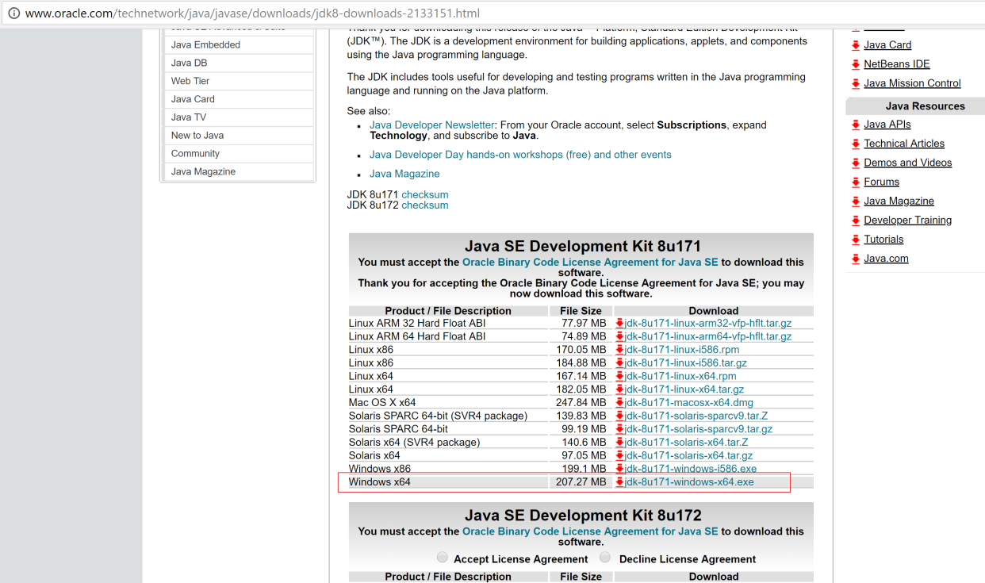

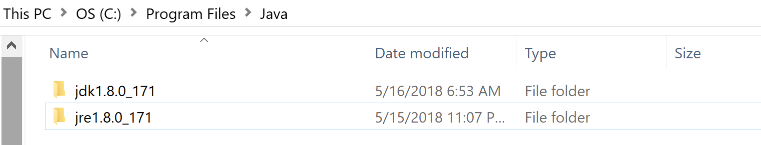

Check environment variables :

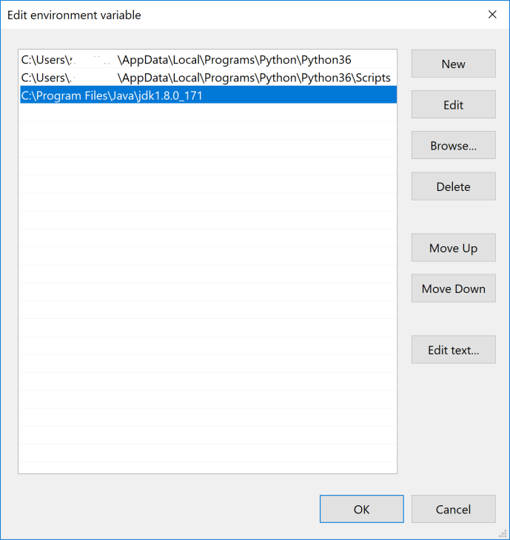

Check java version in command prompt

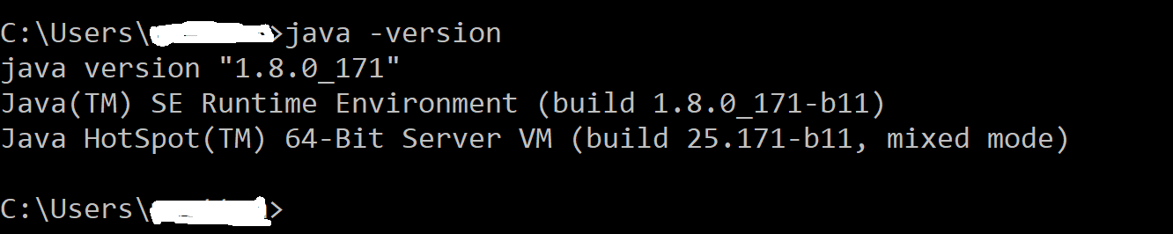

**3.2 Eclipse Installation:**

Step 1 : Go to **eclipse.org** and download latest eclipse version i.e, Oxygen. Click on “Download 64 bit”

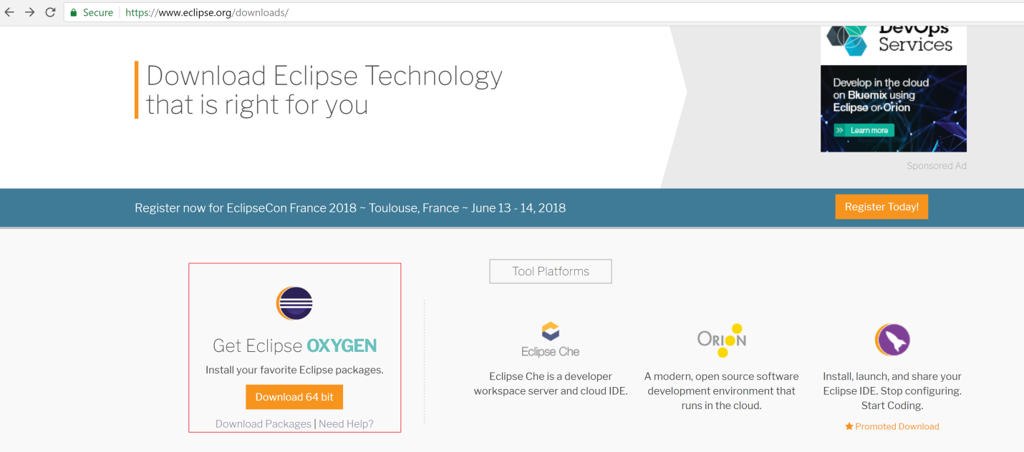

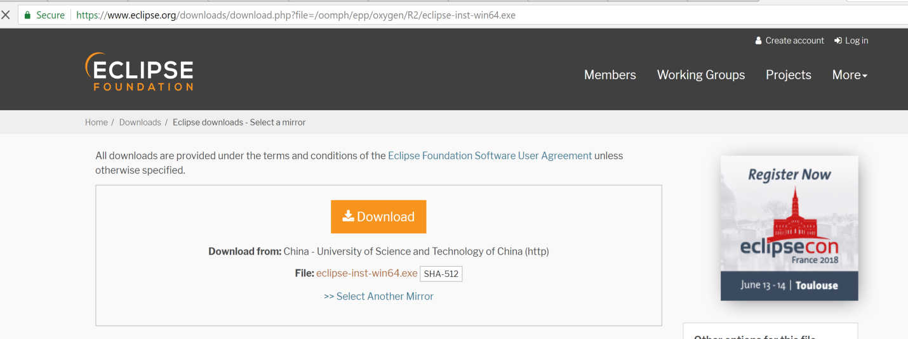

**3.3 Python integration with Eclipse :**

Help -> Install New software -> Click on **Add** button then enter pyDev, [http://www.pydev.org/updates](http://www.pydev.org.updates) and click on Ok button.

Select PyDev check box under Name as below and click on Next button

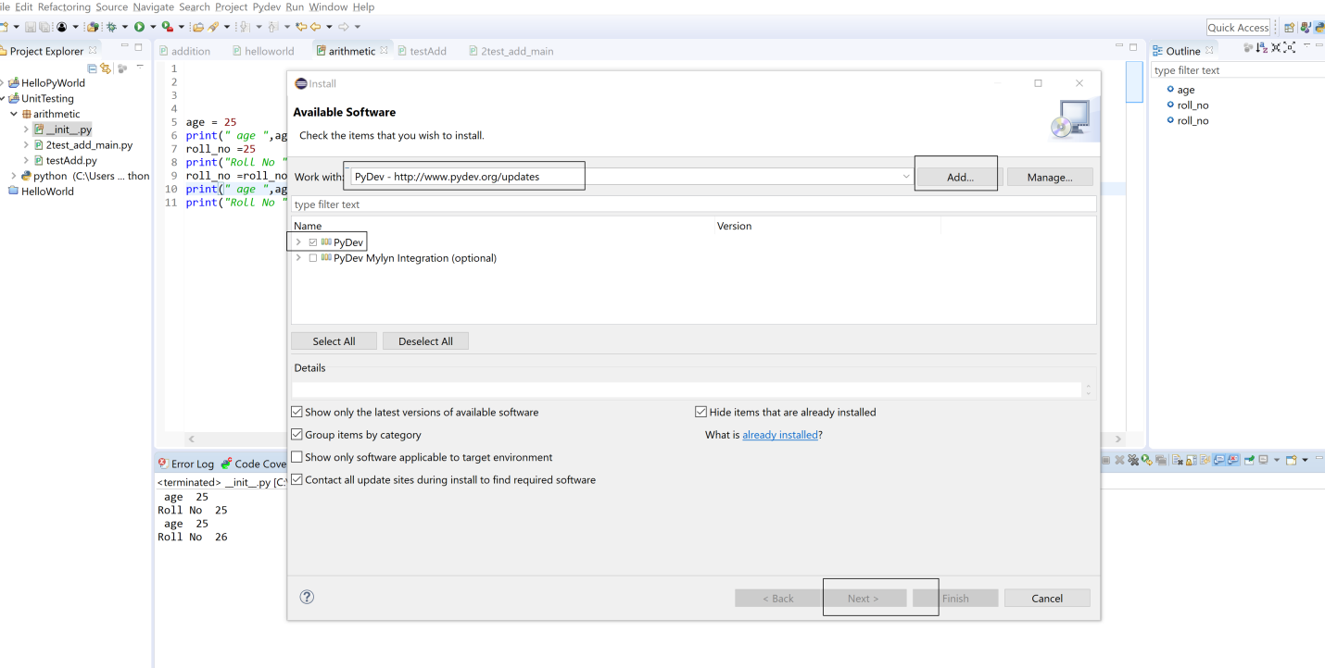

Restart Eclipse if required.

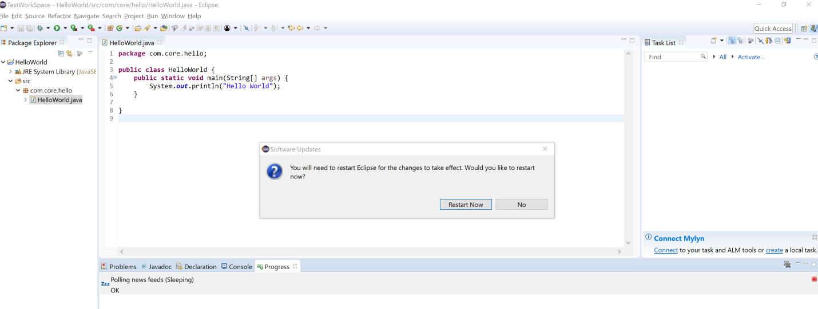

Open python perspective :

Window -> Perspective -> open Perspective -> other ->pydev -> open

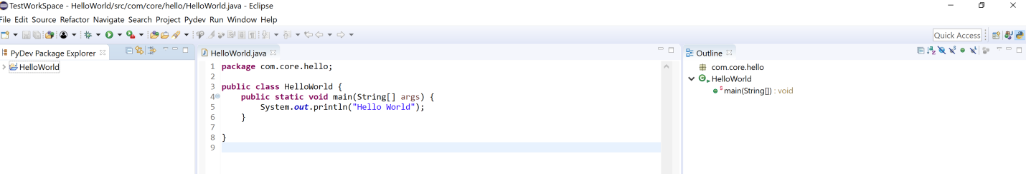

Create new python project :

Step 1: Add python interpreter before creating new project

Window -> Preferences -> Python interpreter

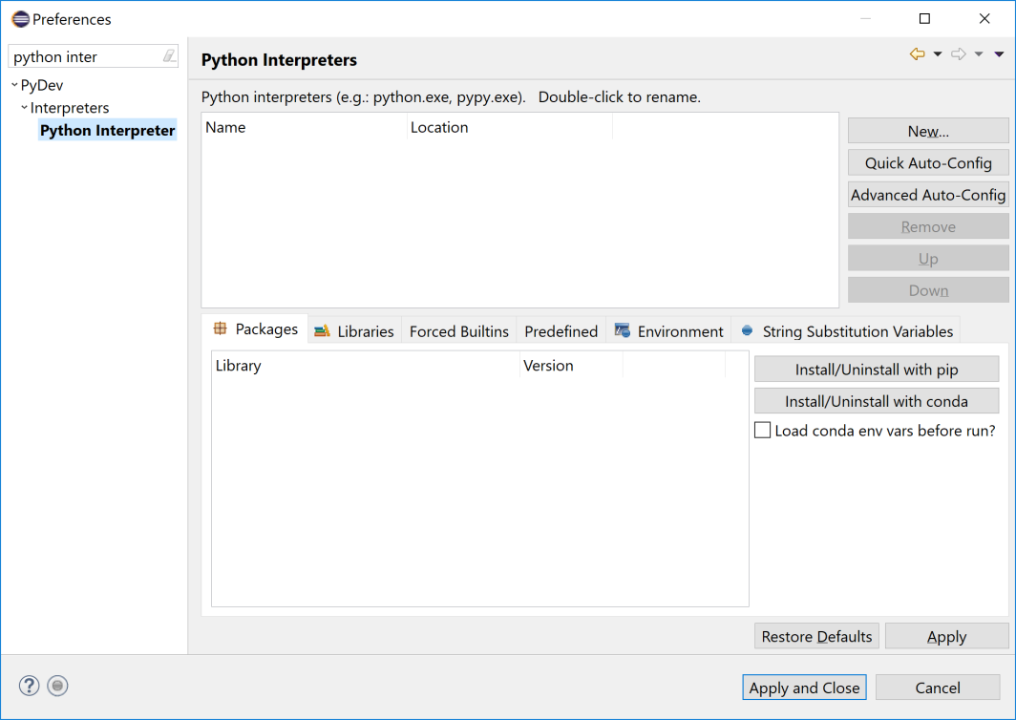

Click on Quick Auto-config.It will add interpreter automatically as below.

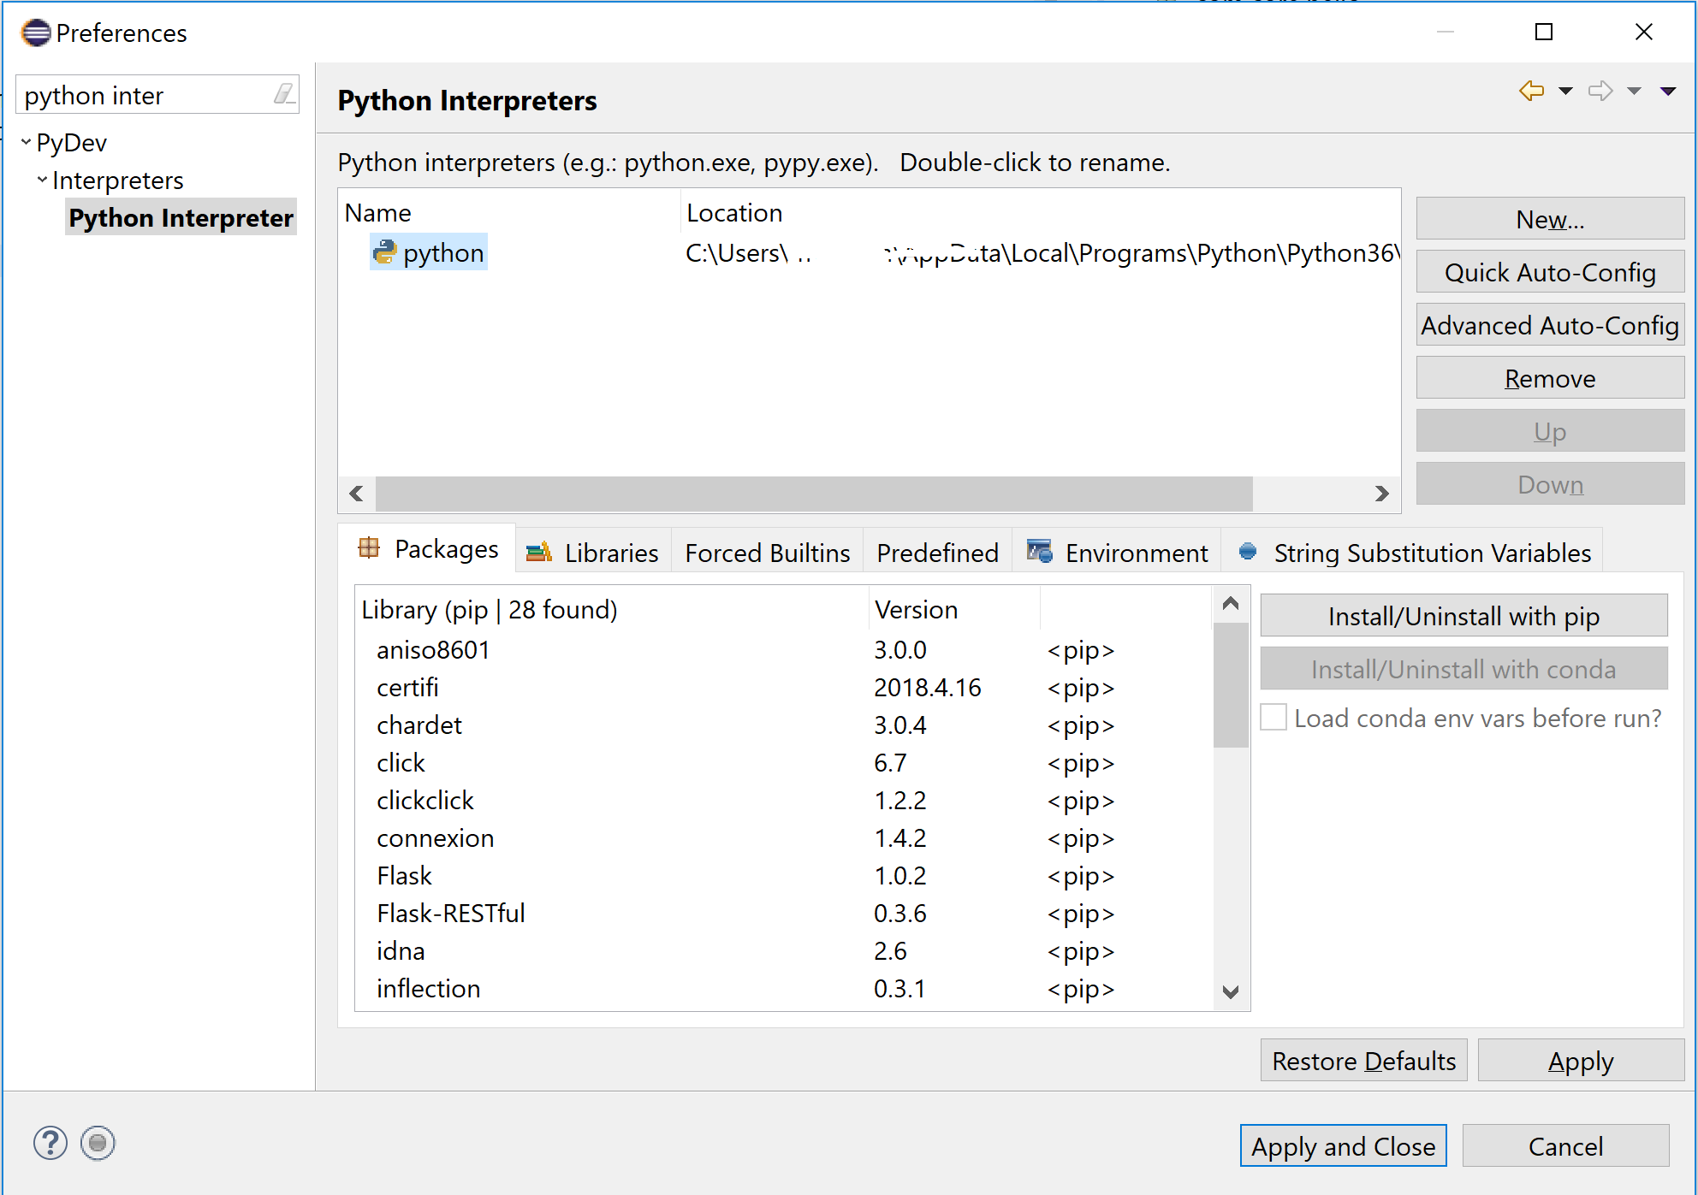

Click on Apply and Close button above.

**3.4 Create new Python project :**

File -> New ->Pydev project

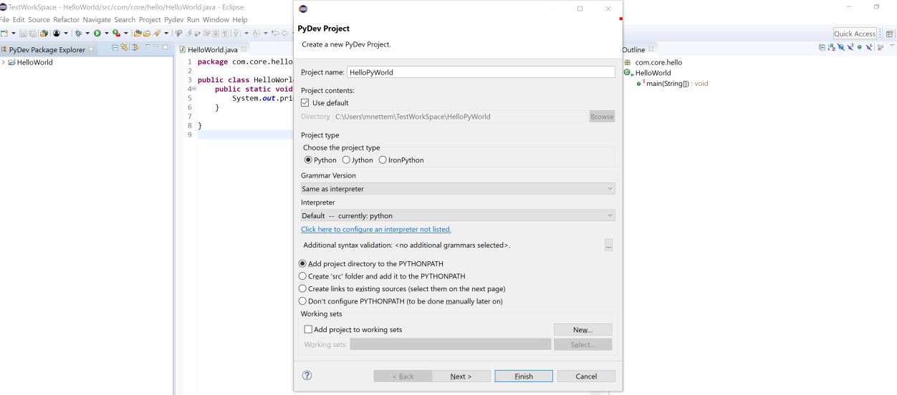

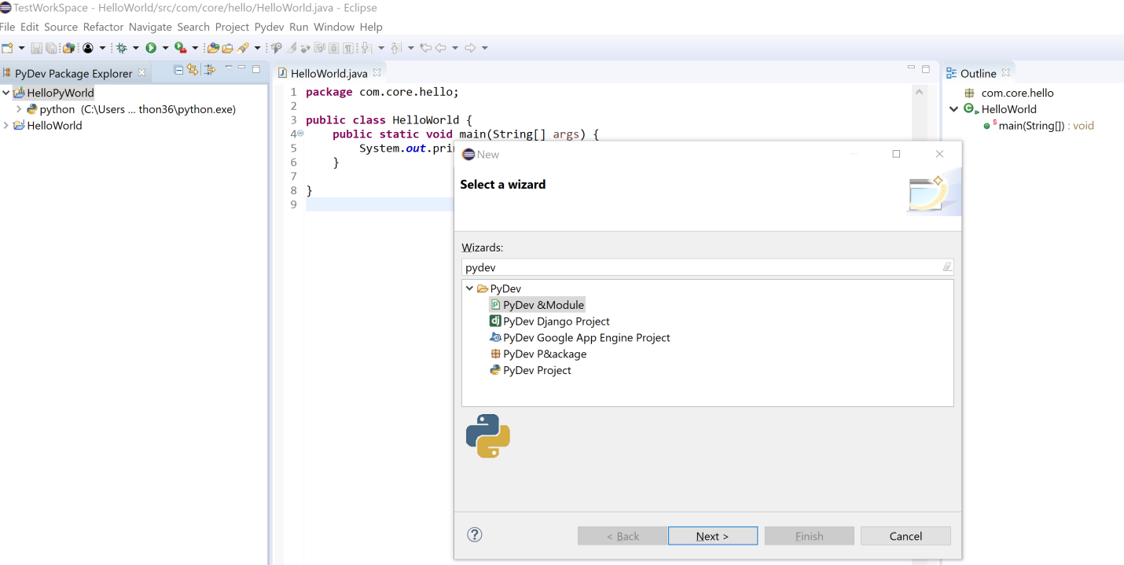

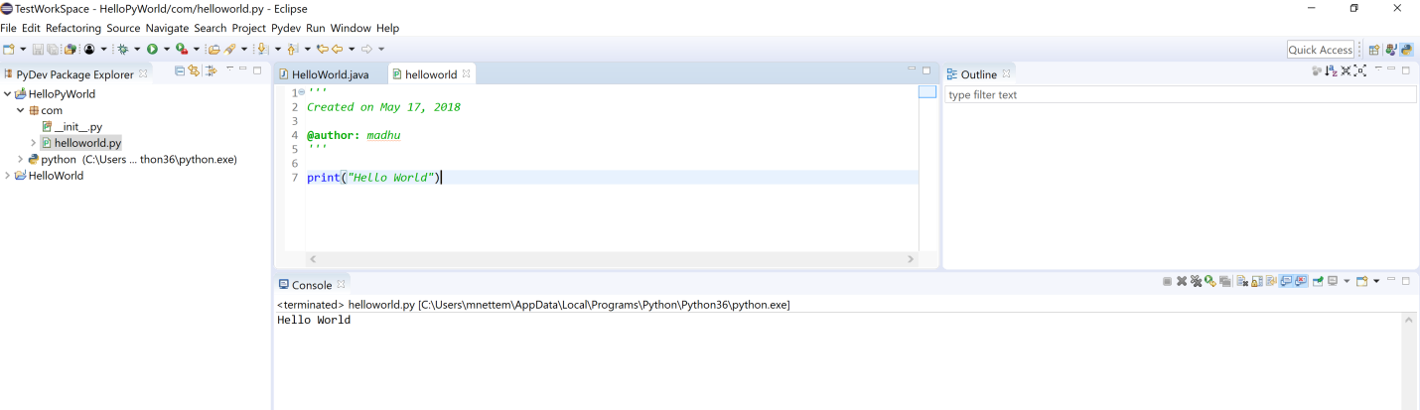

**PYCHARM INSTALLATION:**

https://www.jetbrains.com/pycharm/download/#section=windows

Download **Community** version.

Installation Directory:

C:\Program Files\JetBrains\PyCharm Community Edition 2021.2.1\bin\**pycharm64.exe**

**Open pycharm:**

**File – settings – Interpreter – (Console / python console) -> Python Interpreter(add interpreter)**

**Create Project : File 🡪 New Project**

**(C:\Users\madhu\pythonProject)**

**On Project name 🡪 Right click -🡪 New 🡪 Python Package**